Experiment 29
In your GitHub repository, create a new branch called feature-login. Implement a simple login function in a login.py file. After completing the function, create a pull request to merge feature-login into the main branch.
Tasks:
- Create a new branch feature-login.
- Add a login.py file with a simple login function.
- Commit the changes and push them to GitHub.
- Create a pull request from feature-login to main and merge it.

Step 1: Open the GitHub Repository
The existing GitHub repository was opened and the local repository was updated using:
git pull origin main
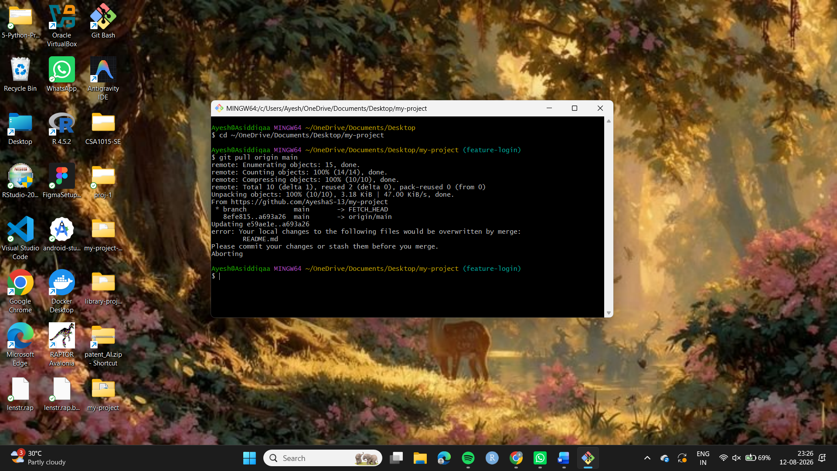
git checkout main
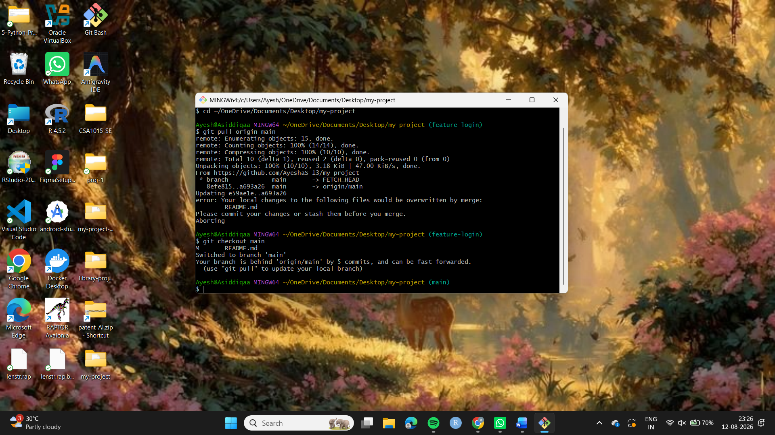
Step 2: Create a New Branch
A new branch named feature-login was created:
i)git checkout feature-login
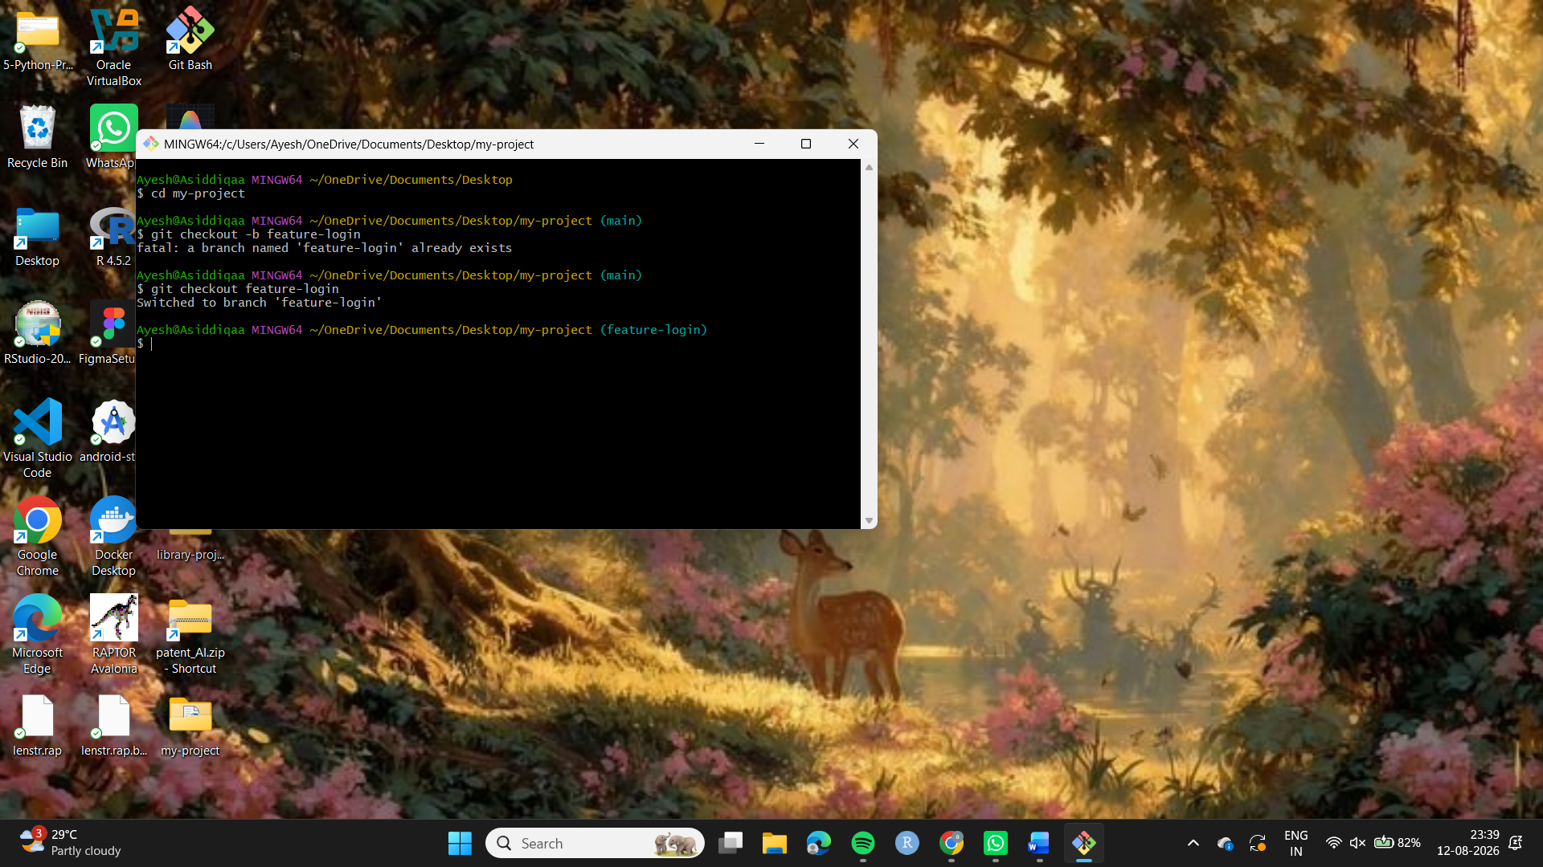
Step 3: Create the login file
A new file named login.py was created and a simple login function was implemented.
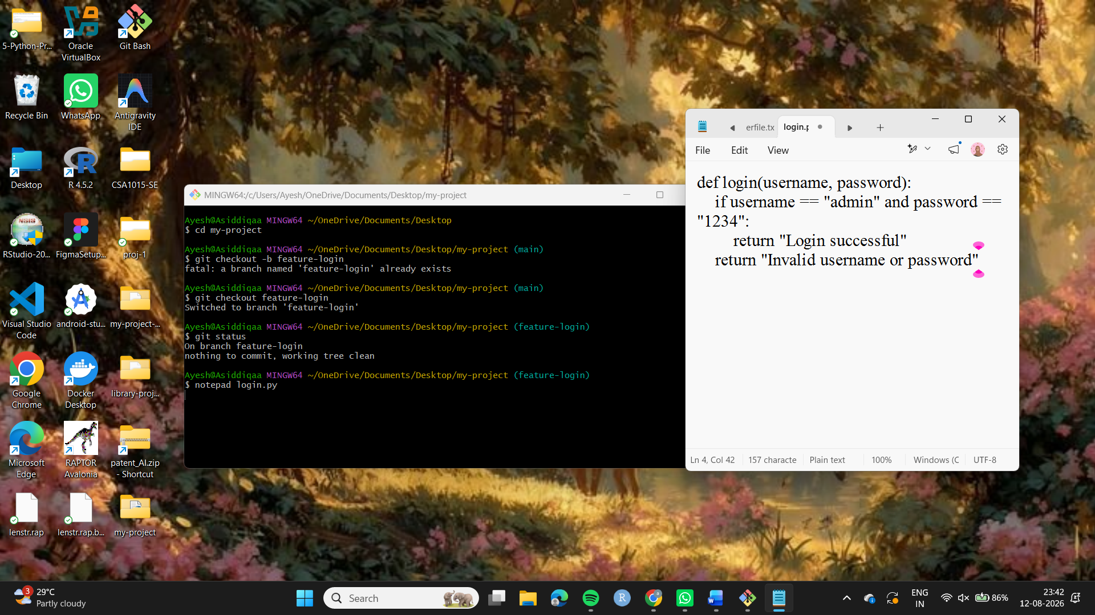
Step 3: Stage the changes
The login file was added to the staging area.
git add login.py
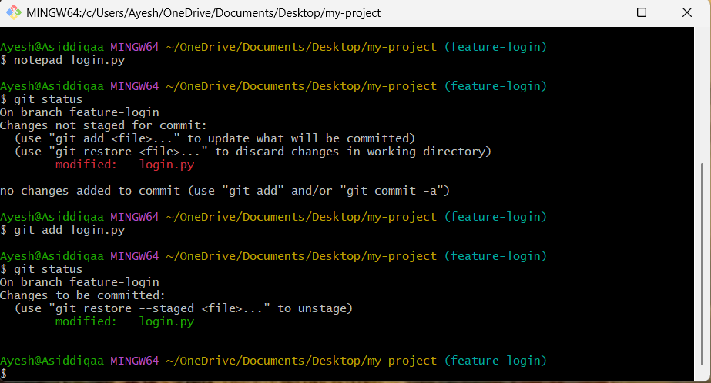
Step 4: Commit the changes
The changes were committed with an appropriate commit message.
git commit -m "Added login feature"

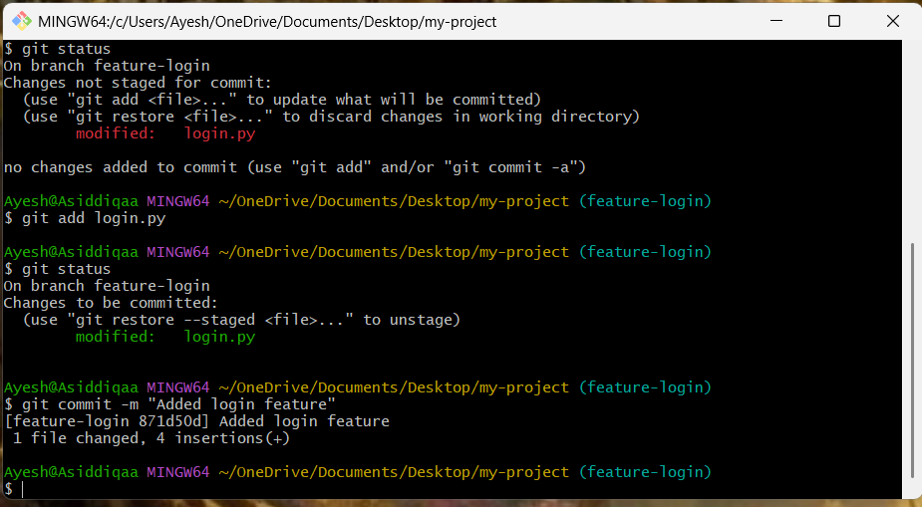
Step 5: Push the feature branch
The feature-login branch was pushed to the GitHub repository.
git push -u origin feature-login
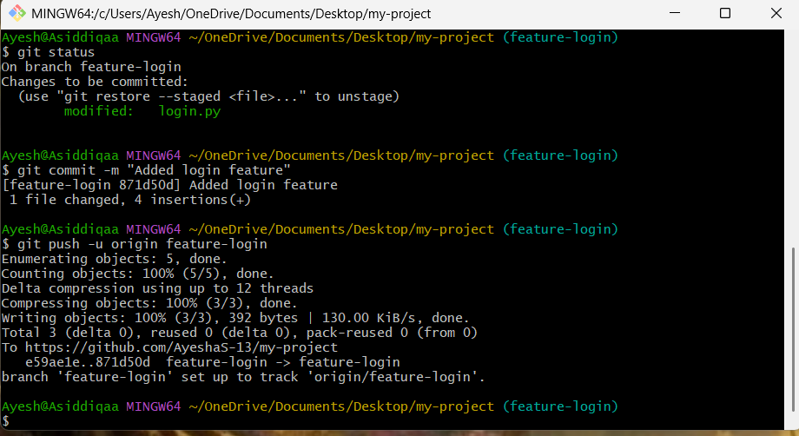
Step 6: Create Pull Request
A Pull Request was created on GitHub from:
feature-login → main
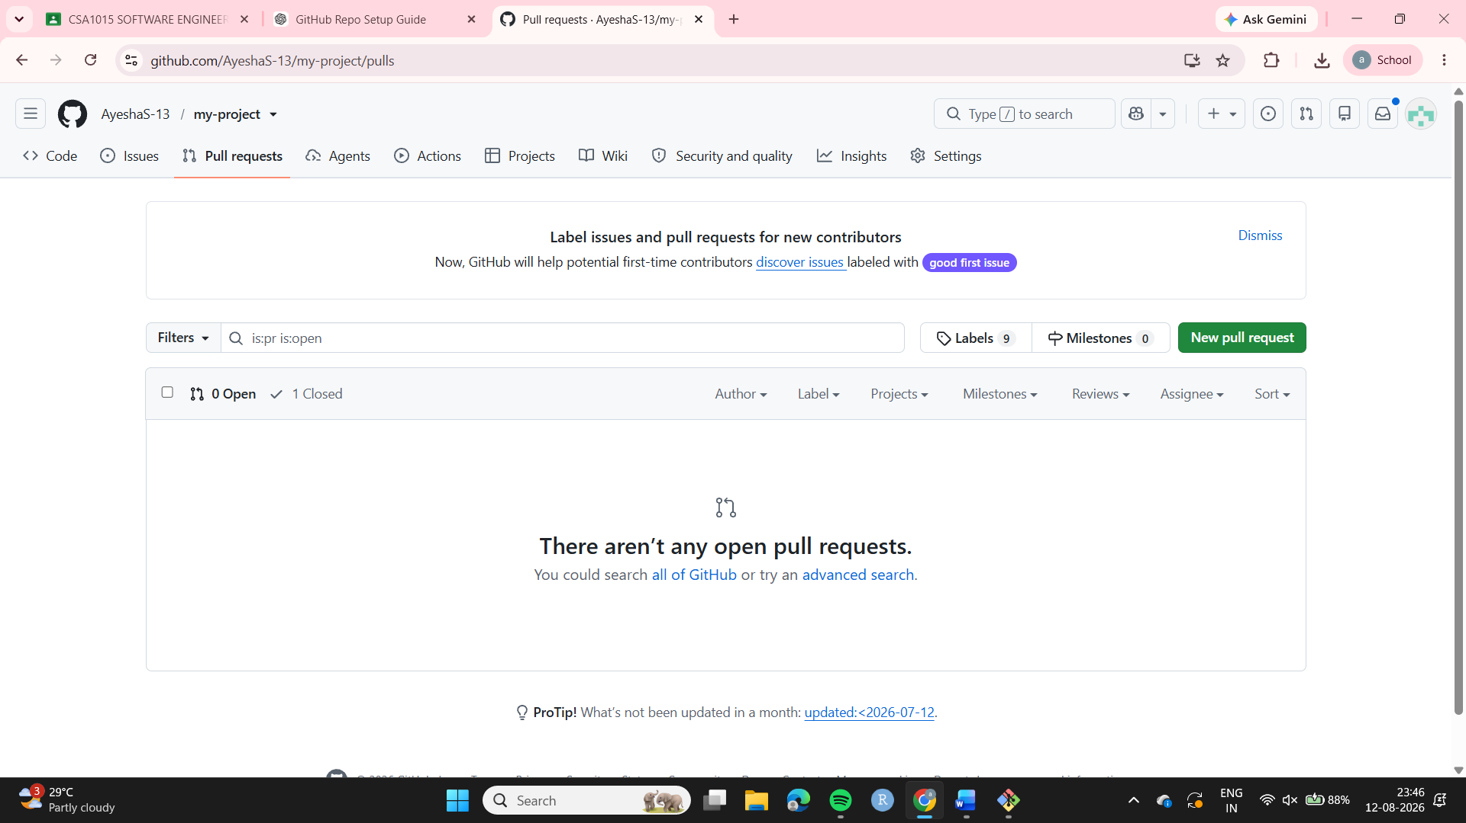
Step 7: Merge Pull Request
The Pull Request was reviewed and merged into the main branch using GitHub.
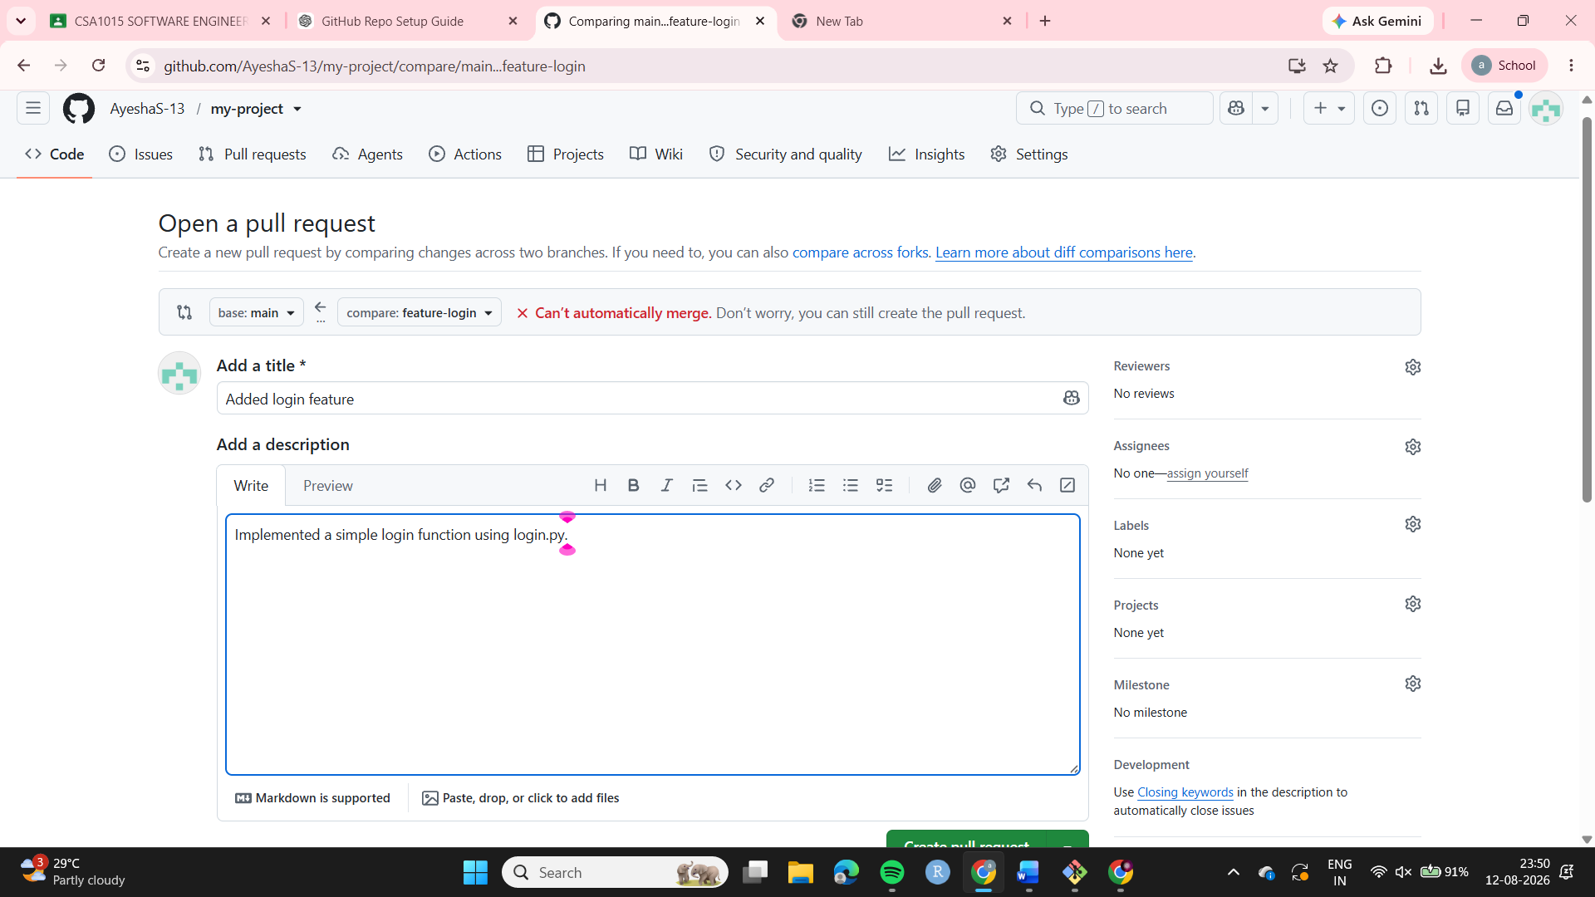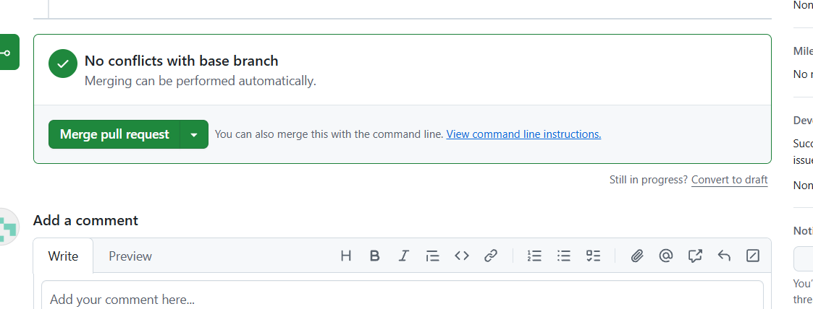
Step 7: Merge Pull Request
The Pull Request was reviewed and merged into the main branch using GitHub
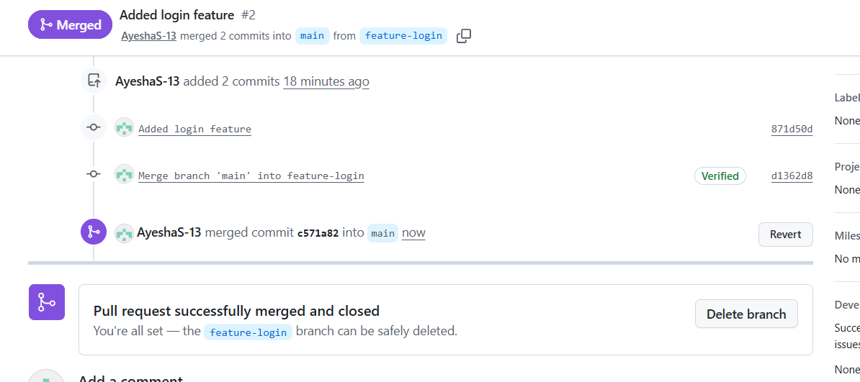
Step 8: Update the local main branch
After merging, the local repository was switched to the main branch and updated.
git checkout main
git pull origin main
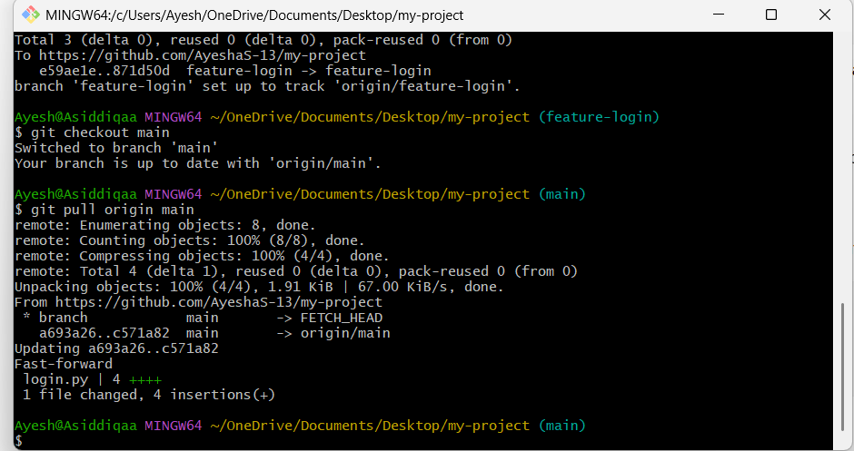
Result
The feature-login branch was successfully created and the login functionality was implemented in login.py. The changes were committed, pushed to GitHub, submitted through a Pull Request, and successfully merged into the main branch

